PROJECT REPORT

S.M.A.R.T OFFICE

Supervisor : Mr.Pritish Varadwaj

Members: P.S.Raghu Chandra (RIT2007022)
G Varun Kumar Reddy (RIT2007019)
Topic:
To provide a system which makes a office paperless and give a common platform that will maintain attendance information, visitors information, reimbursement and all letters tracking and we can retrieve any information any time in different format.
Motivation:
With the advent of computers, many have realization of the “paperless” office. After considering the literature of office management, it is observed that most of simple activities like entering attendance, visitors information, keeping track of letters received and sent from the office etc., are handwritten on paper. Retrieval of the necessary information whenever necessary is a hard and tiresome work. This is the drawback that motivated to develop of general purpose automation software that can be used in offices.. Computers and RDBMS have endless capacity to reduce the traditional use of paper and use database information efficiently than ever. This is the motivating factor that leads to automation of general office activities.
Problem Identification:
The daily activities in a normal office which are paper worked and handwritten.
      - Attendance of the employee is handwritten and often there are chances of people entering wrong data such as entering time when they are late to the office etc.,
      - Accountant has to calculate number of hours a person worked between given dates to calculate salary manually.
      - A receptionist need to enter visitors information manually but when required to retrieve the information of visitors between two given dates would be tiresome job for a human.
      - Employee had to travel for office. So there were travel expenses and other expenses which should be reimbursed, but there was no proper management.

Plan of Work:
We are designing a automation software that provides different functionalities to different users in an office according to their designations to perform their daily activities.
The software is designed for 4 kinds of users namely Administrator, accountant, receptionist and employee.
The use case diagrams for these users are as follows

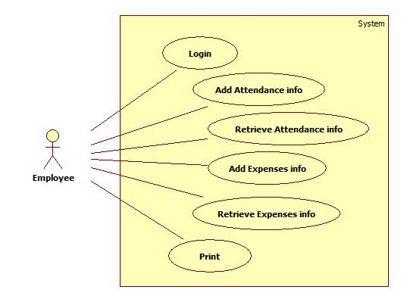

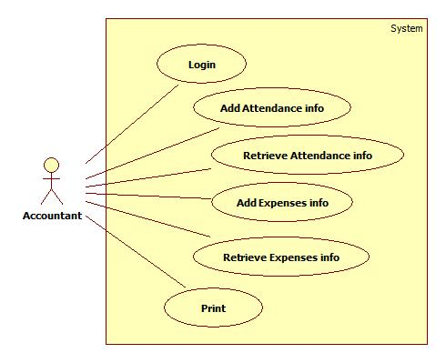
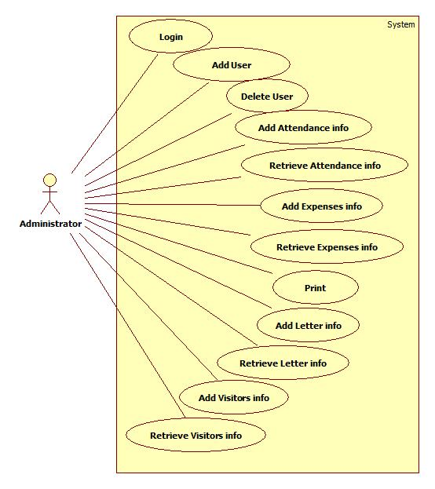
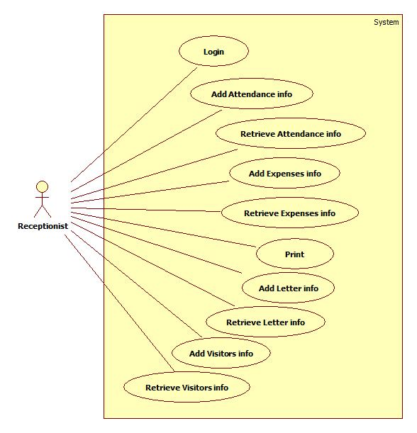
Database Schema:
The E-R diagram for the database is as follows

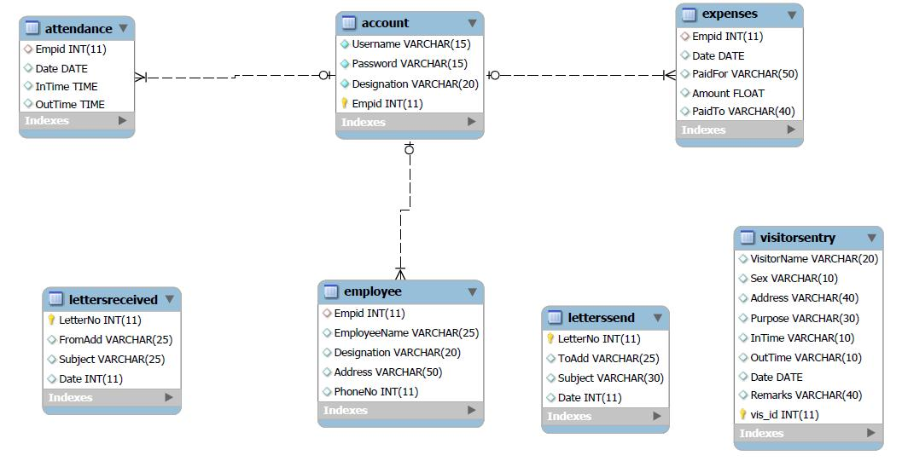

Implementation:
When the user starts the software client, a login window is displayed then the user logins with the his username and password. This username and password is sent to the database server for authentication. After a successful login the MainForm is displayed to user that has all the functionalities based on his respective designation. Use case diagrams are provided above to show their functionalities. A logout button is provided for logging of the session.
This software can work on a single system as well as on LAN. If used on LAN a database server is maintained where all the information is stored. Whenever a client logins’ he is connected to the database server and the client can update information on to the server and can also retrieve any kind of information regarding his work. This database is implemented using SQL.
For security purpose only the administrator has the right to change or alter information.The administrator has the right to view all kinds of information on the database and can also add information to it .Administrator is the person who has the right to create a new user or delete a existing user. If an existing user is deleted, all kinds of information relating to the user on the database will be deleted.
All the users can only enter the information but cannot alter or delete any information. Apart from these, administrator has special privileges to create or delete an account. On deletion of an account all the information related to the user will be deleted. One user cannot view information of other users expect for administrator and accountant who can view everyone’s information.
Attendance can be entered by the user by just clicking on the IN button provided. Once the button is pressed current database server timings are entered into the database and cannot be altered. Similarly while leaving the office. Only one attendance can be entered per day. Apart from this expenses can be entered by the employee himself. Administrator is not given an option to give attendance as he is the head and he does not need to give attendance.
Some functions such as recording visitor’s information and keep track of letters are entered by receptionist only.
Accountant has the privilege to view the expenses list and attendance list of all users so as to perform his work in calculating the salary and reimbursement charges.
A print option is available for every user so that all the necessary forms can be printed whenever he requires them.

Login Window : Initially login window is displayed.

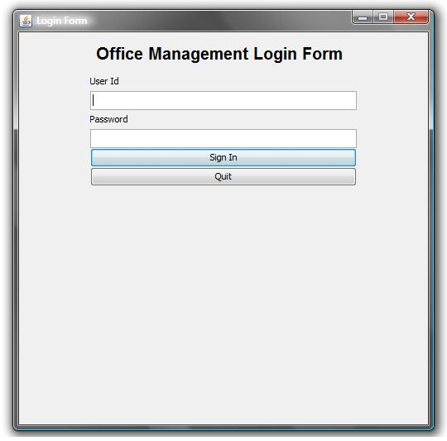

Main form: This is displayed after login, the functions present varies based on the user’s designation. The below figure is the Main form for a receptionist.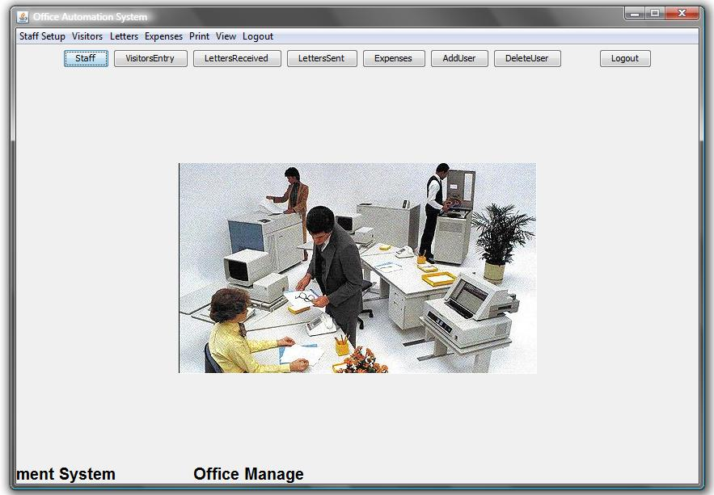
Attendance entrance window for an employee.
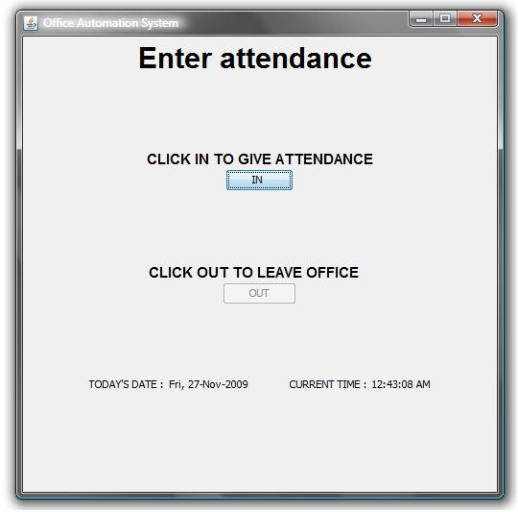

Work Division:
Design and Testing by P.S.Raghu Chandra
- Coding and GUI design with database connectivity by G. Varun Kumar Reddy.

Requirements:
- Any computer that has MYSQL can act as a database server.
- Client computers which has Java installed.

Platform, Tools and Languages:
The language used is Java (JDK 1.6). The programming was done in Netbeans IDE 6.5.1. The software is functional on any platform which is java enabled.
References:
[1] Java Edition 6 api specification: http://java.sun.com/javase/6/docs/api/
[2] Java Complete Reference by Herbert Schildt.
[3] MYSQL reference from http://www.w3schools.com/sql/
[4]Case study on “The Paperless Office: Facts and Fictions”, by Karl L. Smart ,Brigham Young University, Department of Management Communication.

